Create a simple cloud software application for Flight Reservation System using any Cloud Service Provider to demonstrate SaaS

Aim
To create a simple Flight Reservation System using Zoho Creator as a Cloud Service Provider and demonstrate the Software as a Service (SaaS) model.
Procedure
- Login to Zoho Creator and create a new application named Flight Reservation System.
- Create a Flight Details form with fields such as Flight ID, Flight Name, Source, Destination, Date, Time, and Available Seats.
- Create a Passenger Details form to store Passenger Name, Age, Gender, Contact Number, and Email ID.
- Create a Flight Reservation form where users can select the flight, passenger, travel date, and number of seats.
- Add required fields and validations to ensure that users enter valid passenger and flight information.
- Create workflows in Zoho Creator to automatically update the number of available seats after a reservation is made.
- Create reports to display available flights, passenger details, and confirmed reservations.
- Design a simple dashboard containing flight availability, reservation details, and passenger information for easy access.
- Test the application by adding flight details, entering passenger information, and making sample reservations.
- Deploy and access the application through the cloud, allowing users to use the Flight Reservation System through a web browser without installing the software locally, thereby demonstrating SaaS.

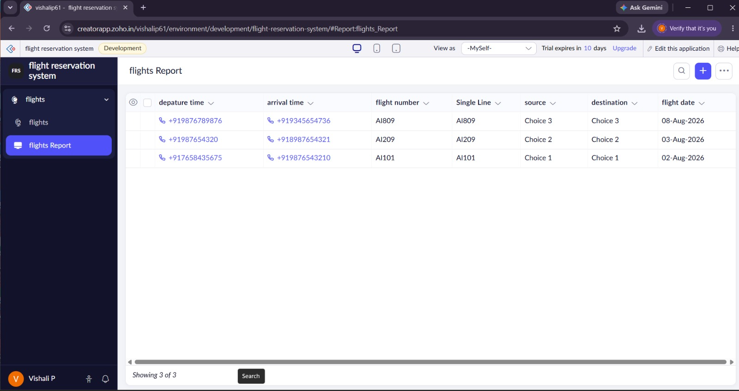
Result
Thus, a simple cloud-based Flight Reservation System was successfully created using Zoho Creator, demonstrating the SaaS cloud service model.

